Neutrino telescopes: Antares & KM3NeT
Management: Prof. dr. M. de Jong
Running period: Antares 2001–2013
KM3NeT 2009–2016

The Antares detector is operational since May 2008. In total, twelve lines have been deployed at the bottom of the Mediterranean sea equipped with 900 optical modules, the ‘eyes’ of the detector. Each optical module houses one large (10”) photo‐multiplier tube (PMT). In November 2010 two detector lines, which had been recovered for repair, were reconnected. Since then, all 12 detector lines are fully operational again. Over the past years, the data-acquisition system, to which the Nikhef group made major contributions, is operating smoothly. Roughly 100 Million muon tracks are recorded each year, about 1000 of which are due to up-going atmospheric neutrinos. In addition, special minimum-bias data taking is externally triggered by the detection of gamma ray bursts by satellites.

Antares data analysis.

On the analysis side, considerable effort has gone into understanding the detector and
obtaining reliable simulations. Optical background and timing resolutions have been measured or constrained by data. The current analyses include a large fraction of 5-line data, but already achieve an angular resolution of 0.5 degrees; which is better than what has been achieved by our colleagues at the South Pole, despite the smaller detector size.

The data of the first two years have been used for a search for cosmic (point) sources of neutrinos. This is a major result of the Experiment, and Nikhef has been the driving force behind this result. Unfortunately, no sources have been found (the most significant 'hot-spot' has a probability of ~2% of occurring as a background fluctuation). Competitive limits on the neutrino flux have been set for a number of source candidates. We will continue this work with two more year of data to be analysed. The same data-set of selected up-going events is also being used to search for correlation of Antares neutrinos with the Highest energy cosmic ray events detected by the Auger detector.

Analyses looking for neutrinos from Gamma Ray Bursts are particularly interesting because the time-correlation with external GRB detection can dramatically reduce the background. As a result, the detection of a few neutrinos can already imply a discovery. At Nikhef, such searches are progressing using both the 'regular' muon tracks, as well as 'shower' events which are caused by electron or tau neutrinos (and neutral-current-interactions). The searches are progressing rapidly and unblinding of these analyses is foreseen for early 2011. A study into detecting GRBs via down-going muons induced by very high energy gamma rays themselves is also in progress.
Studies using simulated down-going atmospheric muon bundles have revealed several observables that may allow Antares to measure the composition of high energy cosmic rays. Cosmic ray composition is interesting as it is related to models of production and their propagation though the Galaxy. The measurement is foreseen to be completed in 2011.

KM3NeT

While Antares is foreseen to keep running for several years to come, the K3MNeT consortium aims at building its successor: a detector with an instrumented volume of at least 1 km. Over the past year, the K3MNeT Technical Design Report has been published and the community has converged on the detector design. This features the multi-PMT optical module designed conceived and designed at Nikhef. In this design, each glass sphere houses many 3” PMT's, as opposed to one large one, which improves the directional sensitivity and the photon counting ability. As a proof-of-principle, it is foreseen to deploy a few multi-PMT optical modules alongside the Antares detector in 2011.

Work is also ongoing at Nikhef on developing reconstruction techniques dedicated for use with the KM3NeT detector design. These studies show that, due to the good optical properties of water, angular resolutions as small as 0.1 degrees will be achievable.

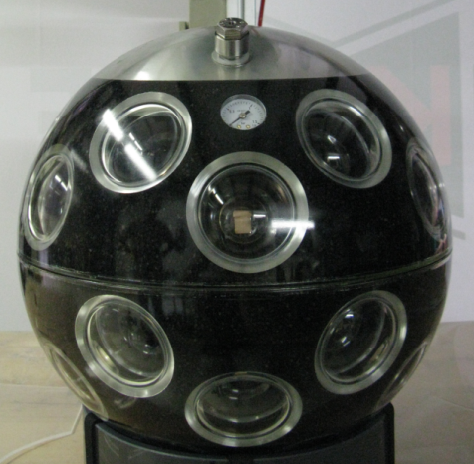Illustration 1: Prototype of a multi-PMT optical module for KM3NeT.

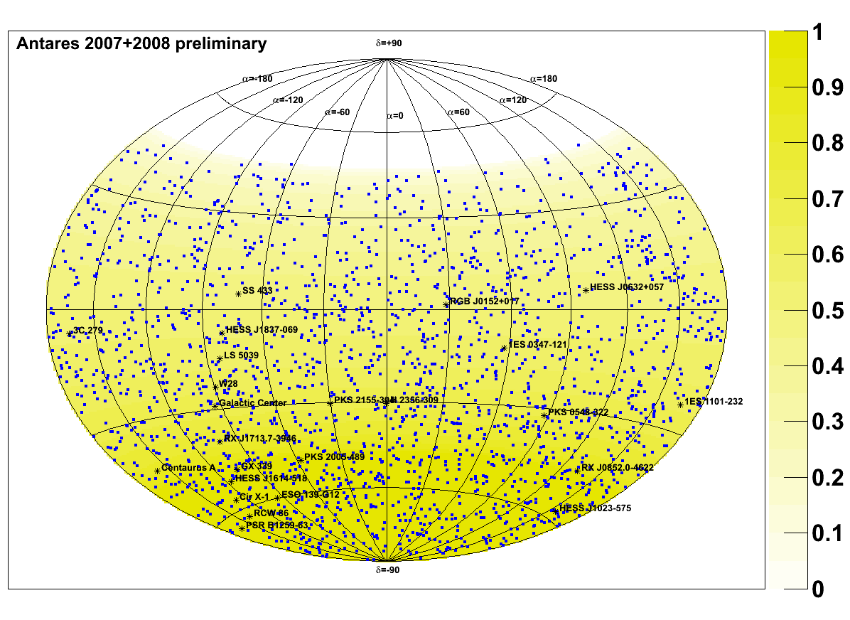Illustration 2: Celestial coordinates of 2040 selected neutrino candidates used for the point source search. The events consist for of mis-reconstructed muons(40%) and atmospheric neutrinos(60%). 24 source candidates are also shown. The yellow shading indicates the fraction of time spent below the horizon.

