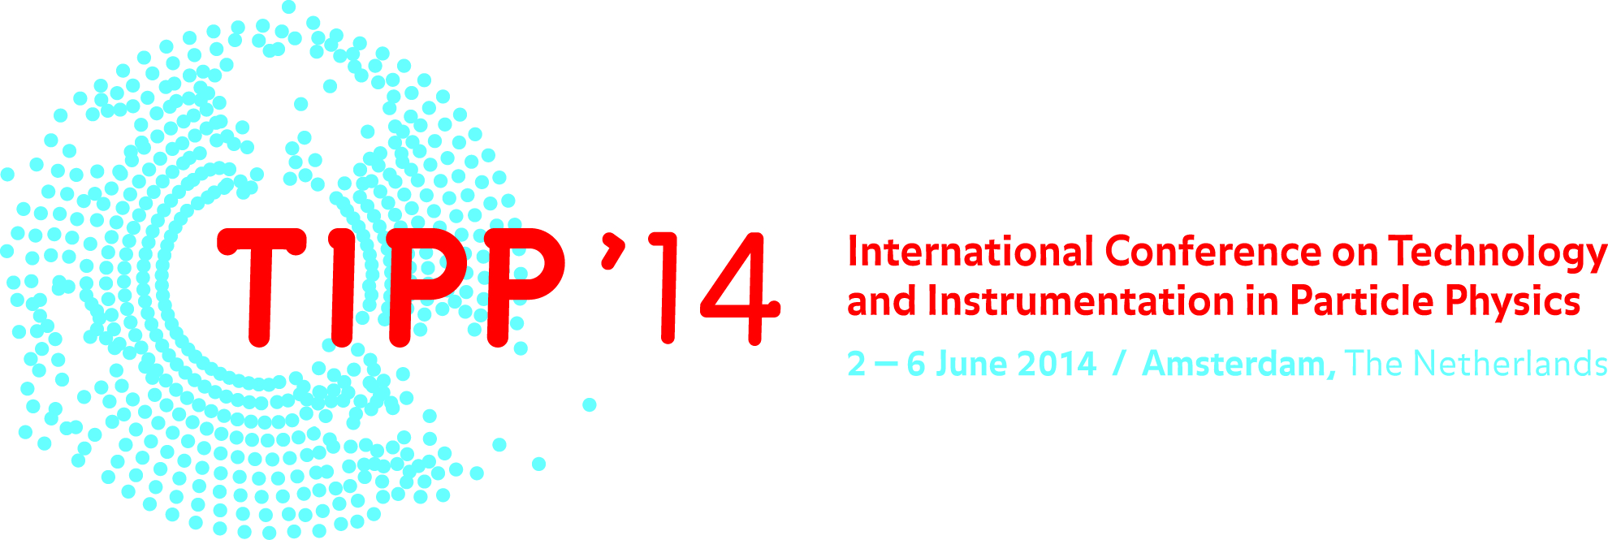

First Bulletin

September 2013

The ***Technology and Instrumentation in Particle Physics 2014*** (***TIPP 2014***) conference will be held at the [Beurs van Berlage](http://www.beursvanberlage.nl) in downtown **Amsterdam from June 2 to June 6, 2014**. TIPP 2014 is the third in the new series of international conferences on detector and instrumentation under the auspices of  IUPAP. The TIPP series of science-driven cross-disciplinary conferences started in Tsukuba (Japan) in 2009 ([TIPP 2009](http://tipp09.kek.jp/)). The second conference was in Chicago in 2011 ([TIPP 2011](http://conferences.fnal.gov/tipp11/)). The TIPP 2014 conference will provide a stimulating atmosphere for scientists and engineers from around the world. The program focuses on all areas of detector development and instrumentation in particle and astro-particle physics and closely related fields.

# Conference topics

The conference program focuses on all areas of detector development and instrumentation in particle and astro-particle physics and closely related fields. It is increasingly important for the field to form industrial partnerships that may lead to new transformational technologies. This medium-sized conference brings together experts from the scientific and industrial communities to discuss current work and to plan for the future. The conference will include plenary invited talks and parallel tracks with contributions outlining state-of-the-art developments in different areas.

The areas of research are grouped as follows :

1. SENSORS
2. EXPERIMENTS
3. DATA PROCESSING
4. EMERGING TECHNOLOGIES
5. TECHNOLOGY TRANSFER

The full program is available on the TIPP2014 agenda server on the [CERN Indico system](http://indico.cern.ch/conferenceDisplay.py?confId=192695).

# Abstract submission

We encourage contributions on the performance of operating detectors and instrumentation as well as on R&D activities and future plans. Of particular interest is how the current technology enhances or limits physics reach and how novel research can respond to these challenges. We also encourage the presentation of new ideas and forward-looking talks on future opportunities that have the potential to transform the field. One of the goals of the conference is to explore innovative solutions in instrumentation that will further enable our scientific exploration. As such, all phases of detector R&D are relevant to the topic of the conference.

Abstract submission will open on December 2, 2013. The deadline for abstract submission is January 31, 2014. Submission takes places through the TIPP2014 web site (www.tipp2014.nl). Acceptance notifications will be sent out on February 15, 2014. Abstract submission guidelines for Tipp2014 will be made available in due time on the conference web site.

# Registration

Starting on November 1, 2013 people are invited to register online via the TIPP2014 web site. Online registration is possible until May 19, 2014. Walk-in registration at the conference is possible.

Standard registration fee: The conference fee is EUR 550 if registration is completed and payment received not later than April 1, 2014.

Late registration fee: Starting April 2, the registration fee will be EUR 650.

The registration fee covers participation to all sessions, coffee breaks, lunches, welcome reception and proceedings publication fees.

Limited funds are available for the students who may need financial support. Students applying for financial support should submit an abstract and apply for the support at the moment of registration, including a recommendation letter from their advisor. Since funds are limited, we encourage applicants to register as soon as possible and we will not be able to accept requests after April 1, 2014.

# Proceedings

Conference proceedings will be published in an open-access journal covering all physics disciplines. Author Guidelines for Tipp2014 will be made available in due time on the conference web site.

# Overview of Important dates

- November 1, 2013 Starting date for abstract submission

- November 1, 2013 Starting date for online registration

- January 31, 2014 Deadline for abstract submission

- February 15, 2014 Notification of acceptance of abstracts

- May 19, 2014 Deadline for online registration

# Visa

Participants are invited to check with their local travel agency regarding any visa

requirements to enter the Netherlands. Application for letters of invitation will be accepted by the Organizing Secretariat before April 1 2014. These documents cannot grant any financial support by the organizers.

# Venue

TIPP 2014 will be held at the [Beurs van Berlage](http://www.beursvanberlage.nl), a building with a rich history and beautiful architecture. The Beurs van Berlage was built between 1898 and 1903 under the auspices of the famous architect H.P. Berlage. A that time, the building generated some controversy, but today it is considered to be a prime example of modern Dutch architecture.

Since the meeting is held right in the center of downtown Amsterdam, participants are strongly discouraged to rent a car. Please use public transportation to reach the conference site. Once at the conference site, everything you would need is within walking distance. The Amsterdam metropolitan area is served by a major airport, national rail stations and other forms of public transportation.

## Airport

Amsterdam Airport Schiphol provides direct connections to 317 European and intercontinental airports in 98 countries. With passenger numbers totalling 51 million, Amsterdam Airport Schiphol ranked as Europe’s fifth-largest passenger airport in 2012. Schiphol train station is situated directly below the airport. You can pick up a free baggage trolley from the platform. Via Schiphol Plaza, you can walk straight to the departure or arrival hall.

How to reach the conference venue  
The Beurs van Berlage is easily accessible by public transport (see [map](https://maps.google.nl/maps?q=beurs+berlage+amsterdam&ll=52.375743,4.896104&spn=0.007087,0.021136&oe=utf-8&client=firefox-a&channel=fflb&fb=1&gl=nl&hq=beurs+berlage&hnear=0x47c63fb5949a7755:0x6600fd4cb7c0af8d,Amsterdam&cid=0,0,18286565975988533039&t=h&z=16&iwloc=A)). The Amsterdam Central Station is located at walking distance (about 300 meters).

## Lodging

Room reservations at a group discount rate will be possible through the conference web site. Group rates will be available until **XXX**, and are subject to availability. **[Other web sites to book hotels from? Discounts?]**

## Climate

Amsterdam has an oceanic climate, strongly influenced by its proximity to the North Sea to the west, with prevailing westerly winds. Summers are moderately warm but rarely hot. The average daily high in June is 19.7 °C. Light rain or brief showers are common.

# Committees

**International Advisory Committee:**  
    
Laura Baudis - University of Zurich  
Ties Behnke - DESY  
Sergio Bertolucci - CERN  
Jim Brau - University of Oregon  
Marcel Demarteau - Argonne National Laboratory  
Junji Haba - KEK   
Erik Heijne - Nikhef and IEAP/Czech Technical University Prague  
Christian Joram - CERN  
Yannis Karyotakis - LAPP  
Young-Kee Kim - FNAL  
Lucie Linssen - CERN  
Kenneth Long - Imperial College London  
Ken Peach- John Adams Institute for Accelerator Science  
Cinzia da Via - University of Manchester  
Yifang Wang - IHEP Beijing  
Hitoshi Yamamoto - Tohoku University  
  
**National Program Committee:**  
  
Jos Benschop - ASML  
Jo van den Brand - VU University Amsterdam  
Sytze Brandenburg - University of Groningen   
Harry van der Graaf - Nikhef  
Rick Harwig - University of Eindhoven  
Hans Hofstraat - Philips  
Sijbrand de Jong - Radboud University Nijmegen  
Lina Sarro - University of Delft  
Jurriaan Schmitz - University of Twente  
Dirk Smit - Shell  
Wim Ubachs - VU University Amsterdam   
  
**Local Organizing Committee:**  
  
Niels van Bakel (chair) - Nikhef  
Martin van Beuzekom - Nikhef  
Auke-Pieter Colijn - University of Amsterdam  
Olya Igonkina - Nikhef  
Paul de Jong - University of Amsterdam  
Els Koffeman - Nikhef  
Frank Linde - Nikhef  
Antonio Pellegrino - Nikhef  
Arjen van Rijn - Nikhef  
Jan Visser - Nikhef  
Leo Wiggers – Nikhef

# Conference Secretariat

TIPP 2014 secretariat

Science Park 105,

1098 XG Amsterdam  
Tel:   +31 (0)20 592 5169  
E-mail: [tipp2014@nikhef.nl](mailto:tipp2014@nikhef.nl)

Conference website: www.tipp2014.nl