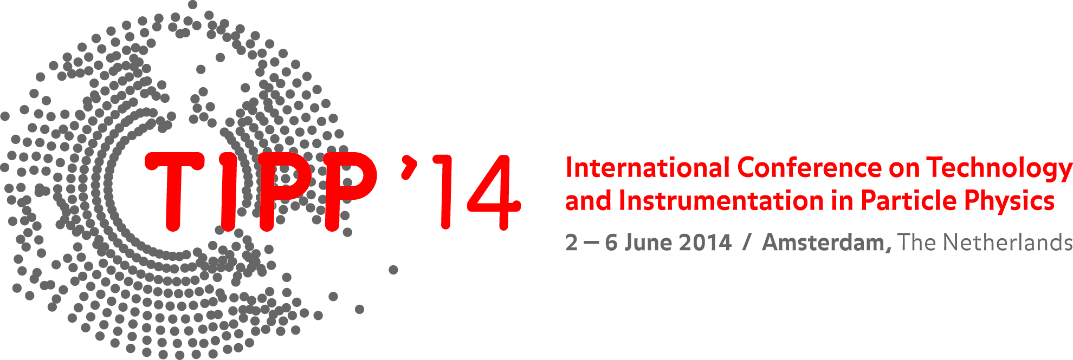

Second Bulletin
May 2013

The Technology and Instrumentation in Particle Physics 2014 (TIPP 2014) conference will be held at the Beurs van Berlage in downtown Amsterdam from June 2 to June 6, 2014. TIPP 2014 is the third in the new series of international conferences on detector and instrumentation under the auspices of IUPAP. The TIPP 2014 conference will provide a stimulating atmosphere for scientists and engineers from around the world.

Conference program

A provisional conference schedule including the scheduling of plenary key note talks is available on the TIPP2014 indico system. We are delighted to have
G. de GERONIMO, G. RAVEN, M. MATTERS-KAMMERER, P. de MOOR, S. DALLA TORRE, J. SCHMITZ, P. RIEDLER, M. DIEMOZ, R. de VRIES, B. DENIS, W. RIEGLER, P. HOMMELHOFF, T. MARRODÁN UNDAGOITIA, H. FRISCH, E. van der BIJ, M. POHL, A. BARYSHEV, L. KAPER as plenary speakers.

The parallel program has five tracks, with sessions on SENSORS, EXPERIMENTS, DATA PROCESSING, EMERGING TECHNOLOGIES, TECHNOLOGY TRANSFER. The poster sessions will take place on Tuesday and Wednesday.
In the framework of the conference a commercial exhibition will be organized which will be situated in the main hall. The admission is free for participants. Opening hours are during the session hours of the conference.

- List of accepted contributions
- Conference time table
- Conference App will be available in Conference4me format

Best presentation prizes

There is a competition for a best oral student presentation and for best poster, please see details at the conference webpage.

Registration

Online registration via TIPP2014 website is possible until May 19, 2014. Walk-in registration at the conference is possible. The registration fee is EUR 650.
The registration fee covers participation to all sessions, coffee breaks, lunches, welcome reception and proceedings publication fees.

Venue

TIPP 2014 will be held at the Beurs van Berlage, a building with a rich history and beautiful architecture. The Beurs van Berlage was built between 1898 and 1903 under the auspices of the famous architect H.P. Berlage. A that time, the building generated some controversy, but today it is considered to be a prime example of modern Dutch architecture.

Internet connection

The wireless connection will be available and details will be provided at the registration desk.

Information for presenters

Speakers are requested to upload their slides in PDF format by June 2nd. The usage of personal laptops for presentations will not be permitted. The talks should be uploaded via indico agenda. The posters can be setup on the first day of the conference and have to be taken down before the closing talk on the last day.

Proceedings

Conference proceedings will be published in Proceedings of Science, the open access online journal organized by SISSA. The page length limits are 10 pages (plenary talks and overview talks at parallel sessions), 8 pages (standard parallel talks) and 4 pages (posters). Author Guidelines for TIPP2014 are available on the conference web site. The deadline for proceedings is June 20.

Conference Secretariat

TIPP 2014 secretariat
Science Park 105,
1098 XG Amsterdam
Tel: +31 (0)20 592 5169
E-mail: tipp2014@nikhef.nl

Conference website: www.tipp2014.nl

